Log on Page

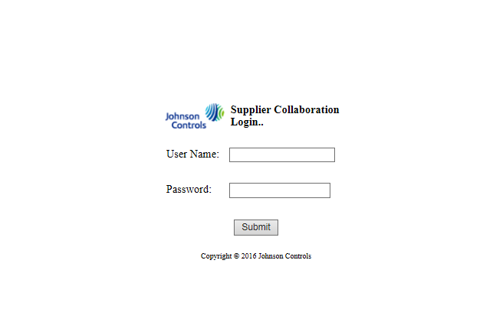

 C:\Users\bselvab\Desktop\E2Open Markups\JohnsonControlsLogo.png



Role associated with uses and plant name (Optional)

Welcome First Name Last Name

**Header and Footer**

Footer

Copyright © 2016 Johnson Controls

Background image

Logoff

**Micro-service Middleware Administration**

**Windchill PLM**

Static information related to Windchill PLM

**E2Open / EDI**

Static information related to E2Open & EDI



Footer

Copyright © 2016 Johnson Controls

Background image

Role associated with uses and Plant name (Optional)

Welcome First Name Last Name

Logoff

* Error in Process -------------- **0**

Action Required

Oracle

SAP

Symix

ECN Details

Process ECN

|  |  |  |  |  |
| --- | --- | --- | --- | --- |
|  | **Change Number** | **Description** | **Plant** | **Status** |
|  |  |  |  |  |
|  |  |  |  |  |
|  |  |  |  |  |
|  |  |  |  |  |
|  |  |  |  |  |

Footer

Header

Go Back

SAP

Symix

Oracle

|  |  |  |  |  |  |  |
| --- | --- | --- | --- | --- | --- | --- |
| **ECN #** | **Plant** | **Change Type** | **Status** | **ECN Requestor** | **ESI Trx Date** | **Process Date** |
|  |  |  |  |  |  |  |
|  |  |  |  |  |  |  |
|  |  |  |  |  |  |  |
|  |  |  |  |  |  |  |

**XML**

**Error Message**

**ECN Description**

ReProcess

|  |  |  |  |  |
| --- | --- | --- | --- | --- |
| **Select** | **PO #** | **PO Description** | **Source** | **Status** |
|  | 89898989 | PO for E2Open test | Symix | **In-transit** |
|  | 89898990 | PO for E2Open test # 2 | Symix | **Transaction Completed** |
|  | 89898991 | PO for E2Open test # 3 | Symix | **Error in Process** |

Action Required

* Error in Process -------------- **10**

Table Paging

Oracle

SAP

Symix

Process PO Data

Pull PO Data

Header

Footer

|  |  |  |  |
| --- | --- | --- | --- |
| **PO #** | **PO Description** | **Source** | **Status** |
| **89898989** | PO for E2Open test | Symix | **Error in Process** |
| **89898990** | PO for E2Open test # 2 | Symix | **Error in Process** |
| **89898991** | PO for E2Open test # 3 | Symix | **Error in Process** |

Submit

PO Details with Edit Option only for selected fields

Table Paging

Error Re-Process

Symix

SAP

Oracle

Footer

Header